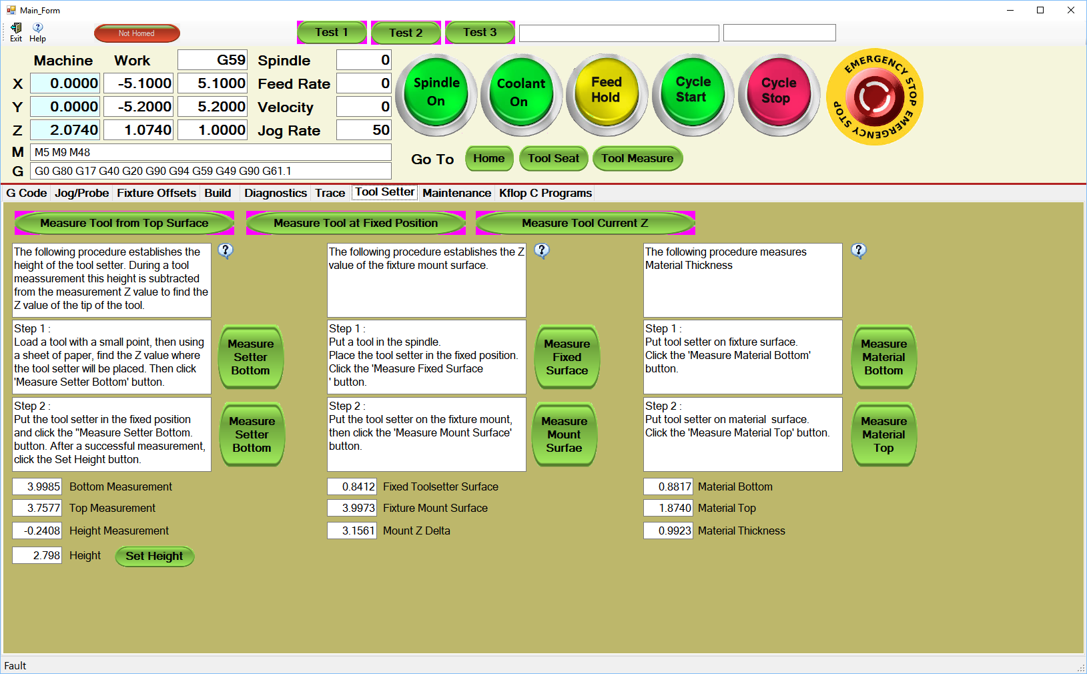
This procedure measures the thickness of material. This is used when using a fixed position tool setter.
First measurement using paper.
Second measurement using tool setter.

Material
Tool Setter
Fixture

